**PART 1**

Write and execute the proper SQL commands to add a field (name: num_movies datatype: int) to the ACTORS table. You will also need to initialize the field value to zero for all existing records in the ACTORS table. (See the [w3 schools page](https://www.w3schools.com/sql/sql_alter.asp) for help with adding a field to an existing table).

Commands for SQL:

1. *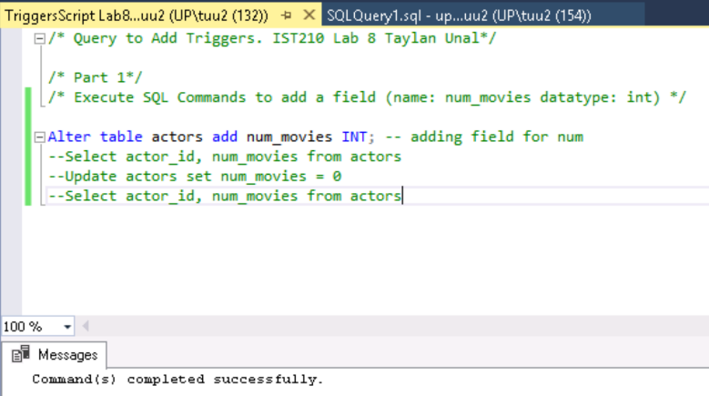Alter table Actors add num_movies INT*

*Command(s) completed successfully.*

1. *Select actor_id, num_movies from actors*

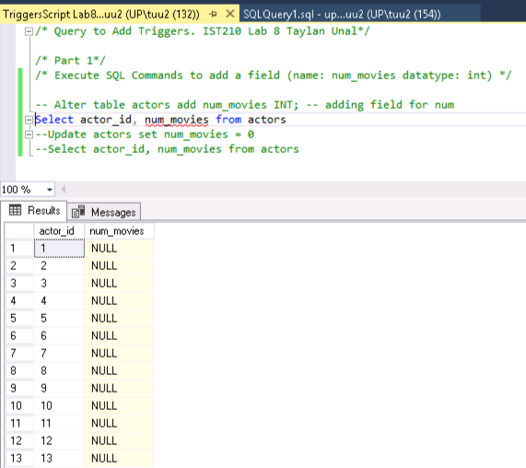actor_id num_movies

----------- -----------

1 NULL 10 NULL

2 NULL 11 NULL

3 NULL 12 NULL

4 NULL 13 NULL

5 NULL

6 NULL

7 NULL

8 NULL

9 NULL

(13 row(s) affected)

1. ***Update actors set num_movies = 0***
2. *row(s) affected)*
3. ***Select actor_id, num_movies from actors***

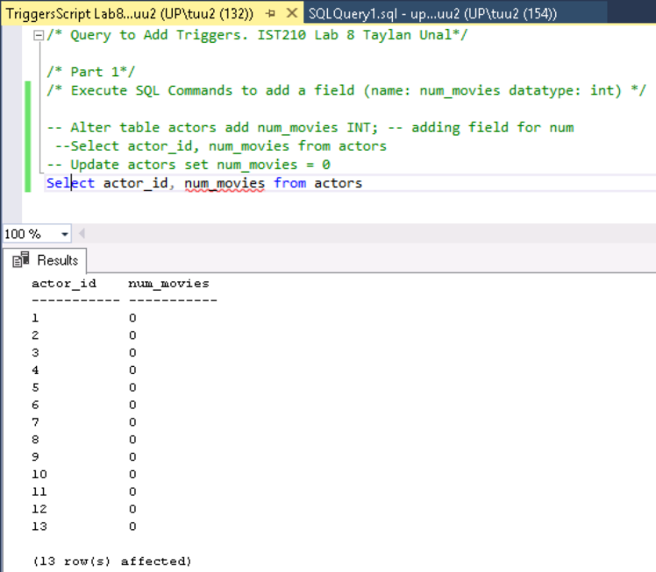 actor_id num_movies

----------- -----------

1 0

2 0

3 0

4 0

5 0

6 0

7 0

8 0

9 0

10 0

11 0

12 0

13 0

(13 row(s) affected)

**PART 2**

Create three triggers for each of the events... INSERT, UPDATE, DELETE. The trigger will either add, subtract or add/subtract the occurrence of the event.

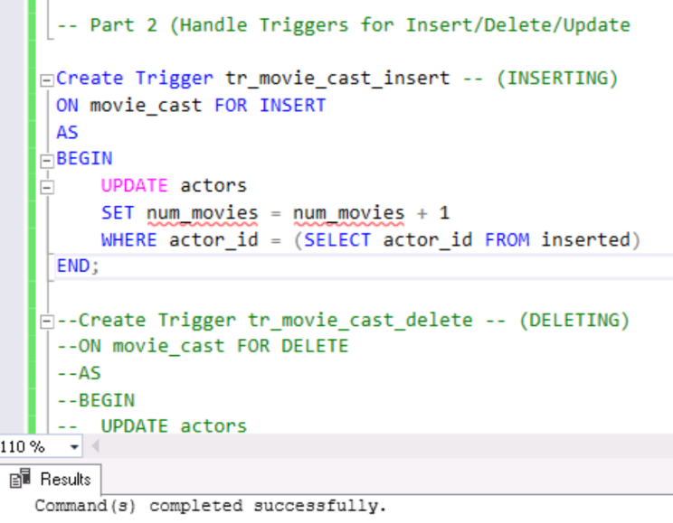Create Trigger tr_movie_cast_insert -- (**INSERTING**)

ON movie_cast FOR INSERT

AS

BEGIN

UPDATE actors

SET num_movies = num_movies + 1

WHERE actor_id = (SELECT actor_id FROM inserted)

END;

*Command(s) completed successfully.*

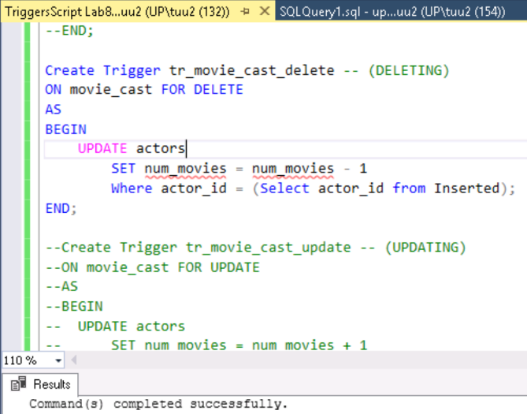Create Trigger tr_movie_cast_delete -- (**DELETING**)

ON movie_cast FOR DELETE

AS

BEGIN

UPDATE actors

SET num_movies = num_movies - 1

Where actor_id = (Select actor_id from Inserted);

END;

*Command(s) completed successfully.*

Create Trigger tr_movie_cast_update -- (**UPDATING**)

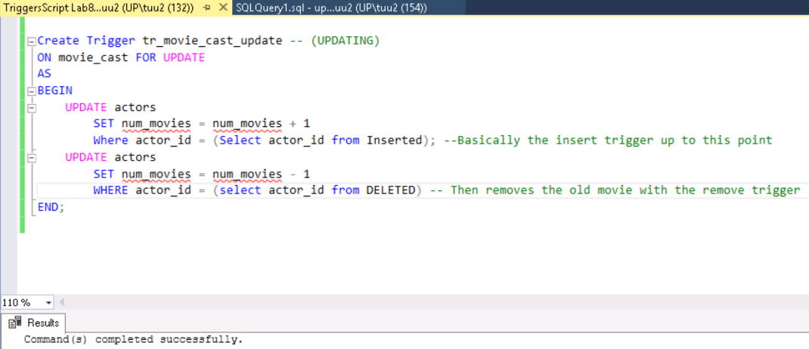ON movie_cast FOR UPDATE

AS

BEGIN

UPDATE actors

SET num_movies = num_movies + 1

Where actor_id = (Select actor_id from Inserted); --Basically the insert trigger up to this point

UPDATE actors

SET num_movies = num_movies - 1

WHERE actor_id = (select actor_id from DELETED) – Basically uses remove trigger

END;

*Command(s) completed successfully.*

**PART 3**

Write and execute SQL commands to test the three events. You need to show the value of num_movies with a SELECT statement before the event and then after the event.

**Before any insertions/updates/deletions:**

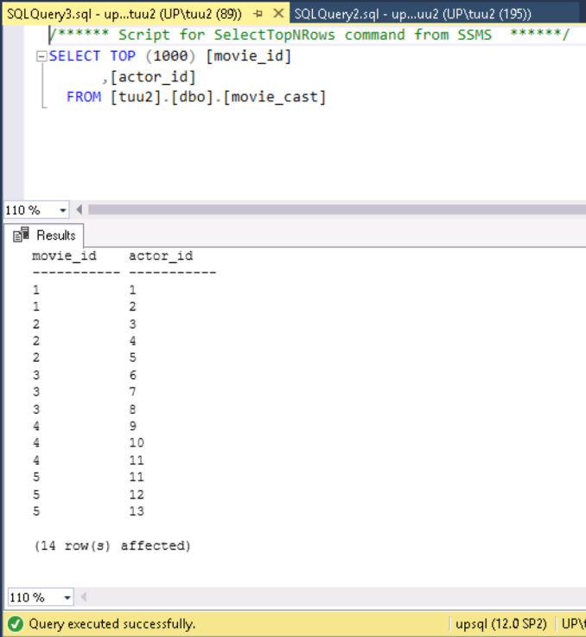actor_id    num_movies

----------- -----------

1           0

2           0

3           0

4           0

5           0

6           0

7           0

8           0

9           0

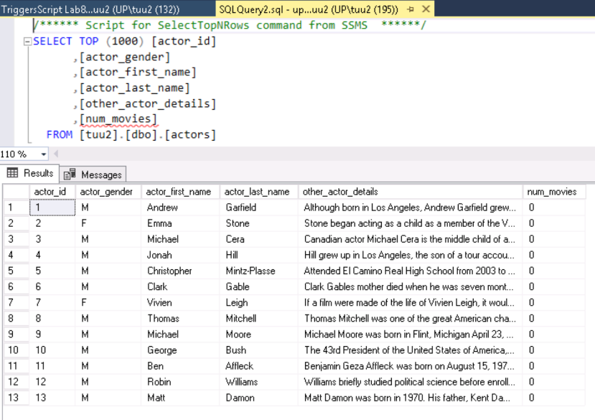10          0

11          0

12          0

13          0

(13 row(s) affected)

Testing Insertion Trigger:

INSERT INTO movie_cast VALUES (5, 3) -- inserting into movie_id and actor_id.

(Adding actor Michael Cera to the movie Good Will Hunting)

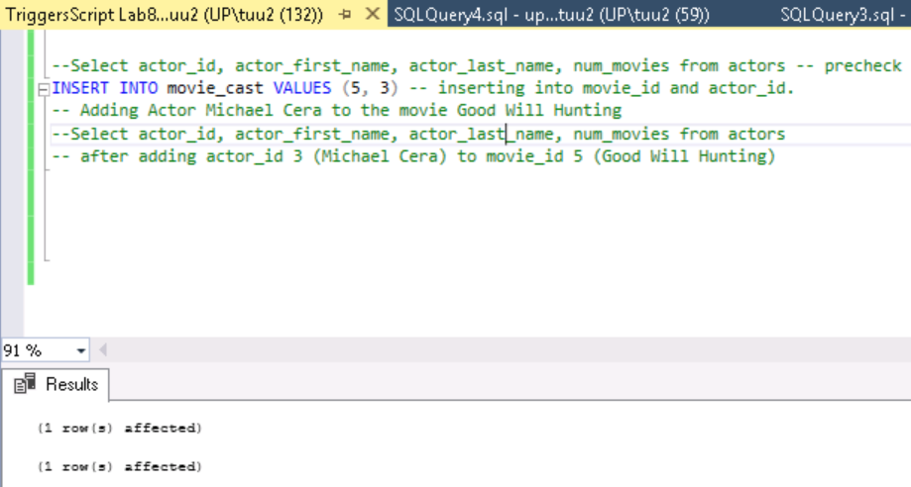

*(1 row(s) affected)*

*(1 row(s) affected)*

Select actor_id, actor_first_name, actor_last_name, num_movies from actors

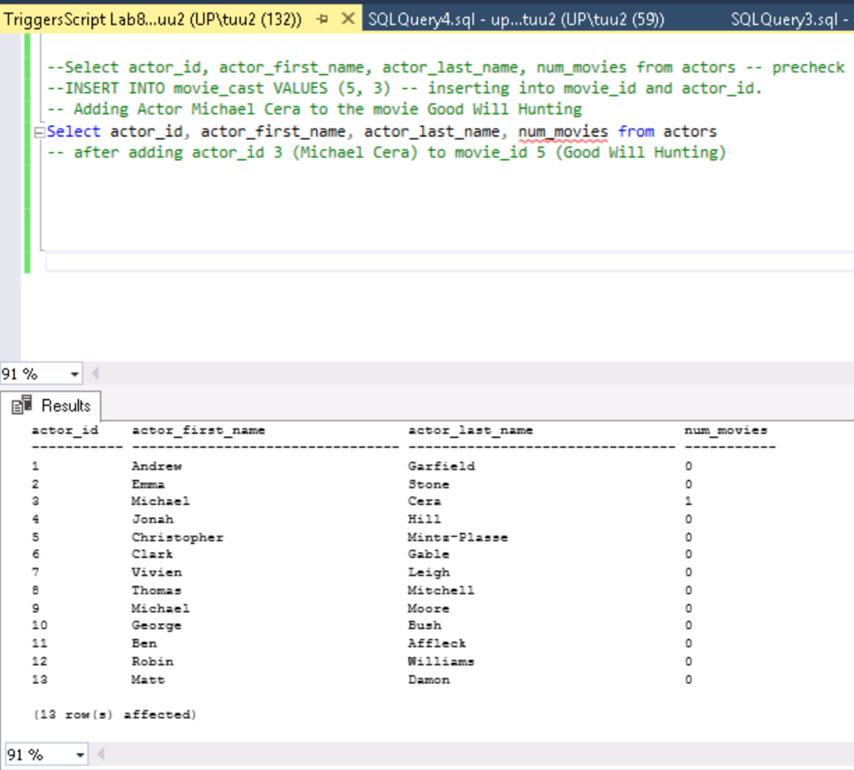(Michael Cera’s num_movies was updated by adding one to num movies after insert trigger)

actor_id    actor_first_name                 actor_last_name                  num_movies

----------- -------------------------------- -------------------------------- -----------

1           Andrew                           Garfield                         0

2           Emma                             Stone                            0

3           Michael                          Cera                             1

4           Jonah                            Hill                             0

5           Christopher                      Mintz-Plasse                     0

6           Clark                            Gable                            0

7           Vivien                           Leigh                            0

8           Thomas                           Mitchell                         0

9           Michael                          Moore                            0

10          George                           Bush                             0

11          Ben                              Affleck                          0

12          Robin                            Williams                         0

13          Matt                             Damon                            0

(13 row(s) affected)

Testing Delete Trigger:

Before deleting any values:

(Michael Cera remains with one movie under num_movies)

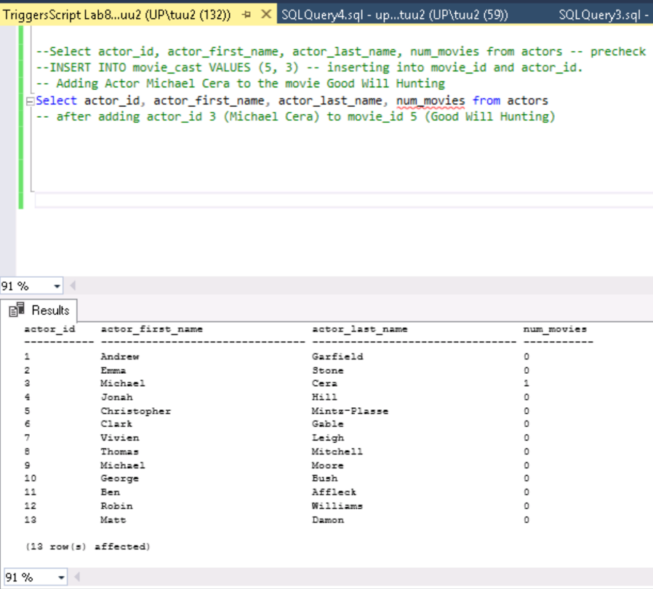

DELETE FROM movie_cast where actor_id = 3 and movie_id = 5

(Remembering that Matt Damon played an great role in Good Will Hunting so remove Michael Cera)

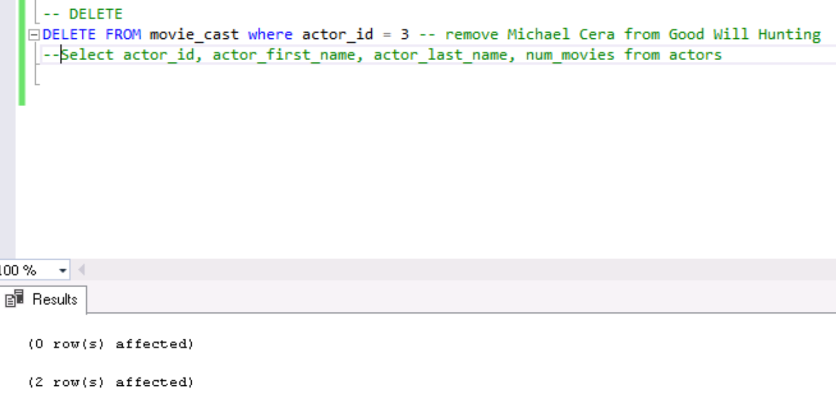

*(0 row(s) affected)*

*(2 row(s) affected)*

Select actor_id, actor_first_name, actor_last_name, num_movies from actors

(make sure that Michael Cera is back to zero for num_movies)

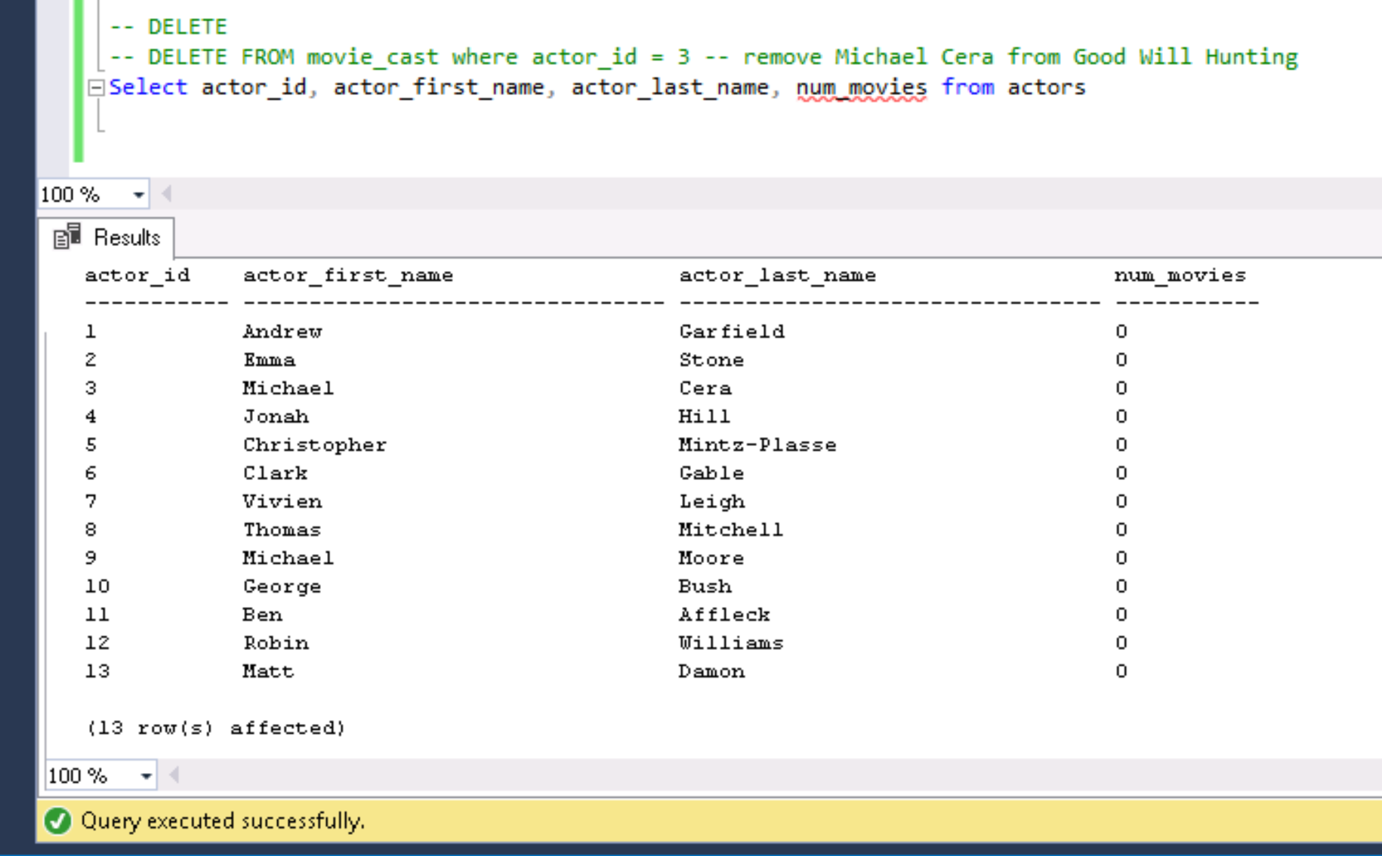

actor_id    actor_first_name                 actor_last_name                  num_movies

----------- -------------------------------- -------------------------------- -----------

1           Andrew                           Garfield                         0

2           Emma                             Stone                            0

3           Michael                          Cera                             0

4           Jonah                            Hill                             0

5           Christopher                      Mintz-Plasse                     0

6           Clark                            Gable                            0

7           Vivien                           Leigh                            0

8           Thomas                           Mitchell                         0

9           Michael                          Moore                            0

10          George                           Bush                             0

11          Ben                              Affleck                          0

12          Robin                            Williams                         0

13          Matt                             Damon                            0

(13 row(s) affected)

Testing Update Trigger:

Before updating any values:



UPDATE movie_cast set movie_id = 2 WHERE actor_id = 10

(Update George Bush’s role in Fahrenheit 9/11 to his role in Superbad)

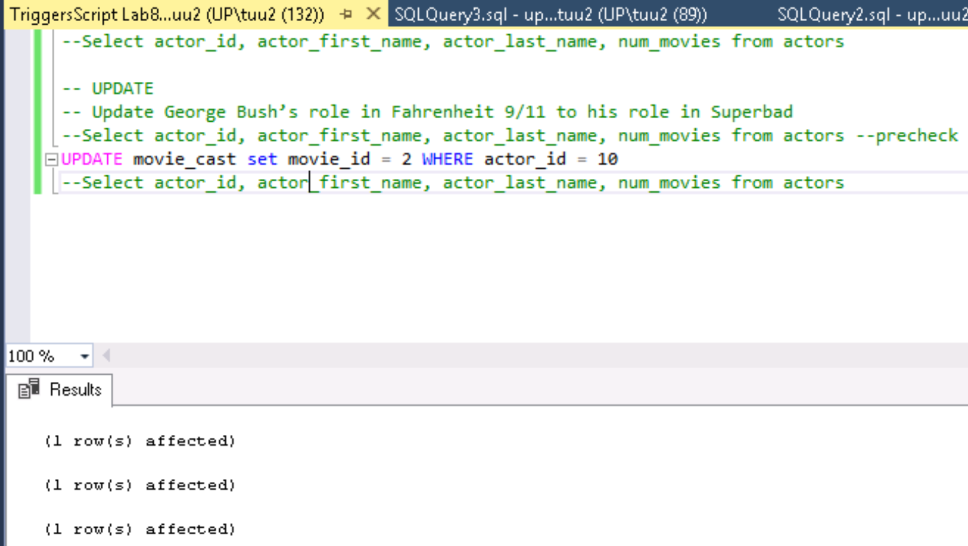

*(1 row(s) affected)*

*(1 row(s) affected)*

*(1 row(s) affected)*